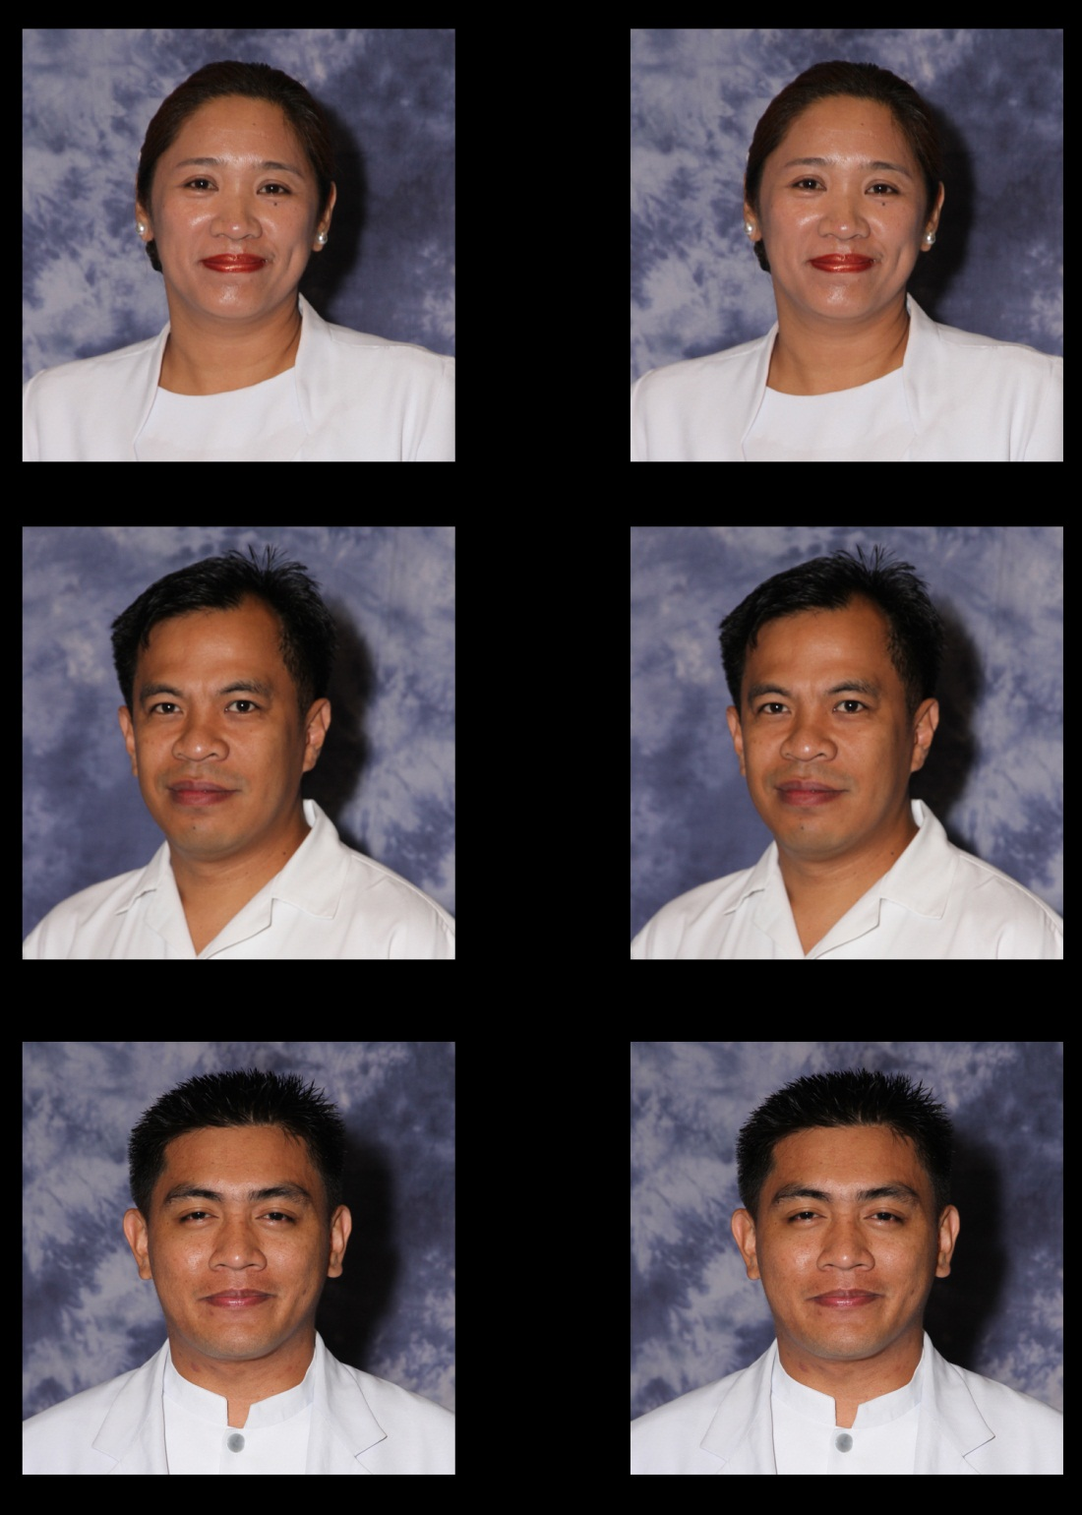

CURRICULUM VITAE

Name: RAMOS, DENNIS GLEN GASCON
Date of Birth: September 8, 1974 Place of Birth: Baguio City Nationality : Filipino
Gender: Male Height: 5’7” Civil Status : Single
PRC License No: 307112 TIN : 922-597-899
SSS No.: 01-1207052-0 PAG-IBIG No.: 10642080405
Baguio Address: 126 Rimando Road, Aurora Hill Baguio City
Home Address: 126 Rimando Road, Aurora Hill Baguio City
Contact Nos: CP No. 0910-729-3050
Email Address: denski74@yahoo.com

EDUCATIONAL BACKGROUND: (from ELEM to COLLEGE/POST-GRAD)
LEVEL | SCHOOL | FIELD OF SPECIALIZATION | YEAR GRADUATED/  UNITS EARNED | DEGREE
Doctorate | St. Louis University |  | 27 | Doctor of Philosophy in Nursing
Post Grad | St. Louis University | Maternal and Child Nursing | 2012 | Master of Science in Nursing
College | St. Louis University |  | 1995 | Bachelor of Science in Nursing
 | Saint Louis High School Aurora Hill |  | 1991 | High School Graduate
 | Dona Aurora Elementary School |  | 1987 | Elementary Graduate

WORK EXPERIENCE: (From Present to Past)
YEAR | POSITION | COMPANY/INSTITUTION | NO. OF YEARS
June 2006 - present | Reviewer | St. Louis University | 14 Years
June 2004 - present | Associate Professor III-2 | St. Louis University
June 2004 - present | Clinical Instructor | St. Louis University
2002- Apr 2004 | Staff Nurse | Al Jazeera Medical Center, KSA | 2 Years
1998 - 2001 | Private Duty Nurse | Salustiano and Severina Llaneta  Ma. Luchi Dizon
1996 - 1997 | Clinic Nurse | Dr. Antonio Medical Clinic

PROFESSIONAL ORGANIZATION MEMBERSHIP or AFFILIATIONS
NAME OF ORGANIZATION | POSITION
Philippine Nurses Association | Member
Philippine Nursing Research Society | Member
Maternal and Child Nurses Association of the Philippines (MCNAP | Member

RESEARCH INVOLVEMENT
A. FACULTY RESEARCH (SY June 2009- May 2017)
DATE | TITLE | SPONSORING AGENCY | ROLE
January 2017 | Health Promoting Behaviors among older adults | School of Nursing | Mentor/Adviser
May 2016 | Effects of Medium of instruction in the knowledge of BHW in Disaster Preparedness | School of Nursing | Mentor/Adviser
February 28, 2014 | Mapping of the Initial Care when a Child is Diagnosed with type 1 Diabetes | SLU Grant Research | Co-proponent

B. RESEARCH PRESENTATIONS (SY June 2009- May 2017)
DATE | TITLE | SPONSORING AGENCY | ROLE
March 2016 | Effect of Teaching aids in  Disaster Preparedness  among BHW | Baguio City | Poster Presentation
November 26-27, 2015 | Effect of kokolis in reducing blood pressure | Cebu City, Philippines | Podium presentation
October 22-24, 2015 | Effect of MBSR: systematic Review | Davao City, Philippines | Poster Presentation
Aug 5-7, 2015 | Leadership and Innovations in Older Person Care Conference | Lampang, Thailand | Oral Presentation
February, 2015 | Effect of EFT in Reducing Stress | PNRS, YST, Manila | Oral Presentation
October, 2014 | Nurse Metamorphosis: Lived Experiences of Nurses in the RN HEALS Program | ADCPN, Manila | Poster Presentation
February 2014 | Feeding Pregnant mother during first stage of Labor: Revisited | EAFONS, Manila | Oral Presentor
November 29-30, 2013 | Lived Experiences of Adults with CKD | PNRS, Baguio City | Oral Presentor
November 28, 2012 | Effectiveness of Dagdag-ay in stress Reduction | PNRS, Manila Tytana Colleges, Pasay City | Poster Presentor
October 25, 2012 | Caregivers Feeding Practices of severely underweight Children | PNA Convention, Manila | Oral Presentor
October 12,2012 | Effectiveness of Dagdag-ay in stress Reduction | ADCPN Convention, Manila | Poster Presentor
 | Effectiveness of Dagdag-ay in stress Reduction | PNA Convention, Manila | Poster Presentor
 | Implementation of Selected Sections of PD 856 by Private elementary School Canteen | PNRS, Manila Tytana Colleges, Pasay City | Poster Presentor
 | Feeding Practices of Caregivers of Severely underweight children | PNRS, Manila Tytana Colleges, Pasay City | Oral Presentor
 | Caregivers Feeding Practices of severely underweight Children | PNRS, Manila Tytana Colleges, Pasay City | Poster Presentor
 | Feeding Practices of Caregivers of Malnourished children of Baguio City | PNRS, Baguio City | Poster Presentor
 | Feeding Pregnant mother during first stage of Labor: Revisited | PNRS, Baguio City | Poster Presentor

C. PUBLICATIONS (Since 2005-May 2017)
TITLE | JOURNAL/PAPER | DATE
Effect of kolkolis in reducing blood pressure | OAT Access : Journal of Integrative Cardiology (JIC) | June 26, 2015

D. OTHER RESEARCH INVOLVEMENT (SY June 2009- May 2017)
TITLE | SPONSORING AGENCY | DATE AND VENUE | ROLE
“Caregiver’s Feeding Practices of Malnourished Children” (Thesis) | Saint Louis University | October 2012 | Author
Research as Researcher with other researchers
Effect of Mindfulness Based Stress Reduction on stress reduction | Saint Louis University | August- December 2014 | Researcher
Feeding Pregnant Mother during the First Stage of Labour : Revisited | Saint Louis University | September 2014 | Researcher
Effectiveness of Dagdag-ay in Stress Reduction | Saint Louis University | June – October 2012 | Researcher
Caregivers Feeding Practices of Severely Underweight Children | Saint Louis University | November 2011 – March 2012 | Researcher
Research as a Researcher
Lived Experiences of Spouses of Male Strippers | St. Louis University | August – December 2014 | Researcher
SI And EQ of  Elementary School Teachers | St. Louis University | August – December 2014 | Researcher
Research as a preceptor (Graduate)
Lived Experiences of mothers in line of parenting | Saint Louis University | November 2013 – March 2014 | Adviser
Lived experiences of elderly widows of Baguio City | Saint Louis University | November 2013 – March 2014 | Adviser
Effectiveness of Emotional Freedom Therapy in reducing stress | Saint Louis University | November 2013 – March 2014 | Adviser
Effectiveness of IEC Materials in Health Promotion | Saint Louis University | November 2013 – March 2014 | Adviser
Researcher as Adviser (undergraduate)
Health Promoting Lifestyle among older adults | St. Louis University | January 2017 | Adviser/Mentor
Authentic Leadership among Nurses Benguet | St. Louis University | January 2017 | Thesis Adviser
Implementation of Sharp and Needle injury policy | St. Louis University | January 2017 | Thesis Adviser
Effectiveness of Teaching Module among Hypertensive Adults | St. Louis University | May – December 2016 | Thesis Adviser
Maternal practices on premature children | St. Louis University | June 3 2013- May 2016 | Thesis Adviser
Lived Experiences of mothers with mentally challenged children | St. Louis University | August 2015 – May 2016 | Thesis Adviser
Effect of Kolkolis in reducing blood pressure | St. Louis University | August 2014 – May 2015 | Adviser
Lived Experience of Nurses in the RN HEALS Program | St. Louis University | June 2013 – March 2014 | Adviser
Feeding Practices of Caregivers of Severely underweight Children | St. Louis University | June 2011- March 2012 | Adviser
Feeding Practices of Caregivers of Obese Children | St. Louis University | June 2010- March 2011 | Adviser
Lived Experiences of elderly inmates | St. Louis University | June 2009 – March 2009 | Adviser

EXTENSION AND OUTREACH (SY June 2009- May 2017)
TITLE | SPONSORING  AGENCY | DATE &  VENUE | ROLE
Outcomes based Education in Nursing – Syllabus Making | St. Louis University and University of Northern Philippines | May 27-28, 2016 | Resource Speaker
BHW Training | Balakbac, Kapangan, Benguet | May 15, 2015 | Resource Speaker
Trainers Training on PTB and HPN Counseling | Cuba, Kapangan, Benguet | April 30, 2015 | Resource Speaker
Outcome Based Education in the BSN Curriculum | St. Louis University | January 2015  Loaog, Ilocos Norte | Resource speaker
Family Planning Seminar | LGU- Kapangan | October, 2014 | Resource Speaker
Outcome Based Education in the BSN Curriculum | St. Louis University | June 13-14, 2014, SLU | Resource Speaker
Outcome Based Education in the BSN Curriculum | St. Louis University | March 2014 San Fernando, La Union | Resource Speaker
Understanding Child Development | LGU- Kapangan | August 5, 2013  Sayeg Hall, Lomon, Kapangan, Benguet | Resource Speaker
Municipal Nutrition Summit | LGU- Kapangan | July 22, 2013  Sayeg Hall, Lomon, Kapangan, Benguet | Resource Speaker
Family Development Seminar | LGU – Cuba, Kapangan | July 10, 2013  Pakawan Barrio School | Resource Speaker
Family Development Seminar | LGU- Taba-ao, Kapangan | July 9, 2013  Barangay Hall, Taba-ao, Kapangan, Benguet | Resource Speaker
Career Orientation | Ilocos Sur Polythecnic State College | March 5, 2013  ISPSC Hall | Resource Speaker
Reflection and Awakening | Ilocos Sur Polythecnic State College | February 23, 2013  IS{SC Hall | Resource Speaker
Community Clinical Instructor | SLU-SON | June 2006- present

SPECIAL TRAINING/S RELATED TO PROFESSION (SY June 2009- May 2017)

TITLE OF TRAINING | SPONSORING  AGENCY | DATE/VENUE
Seminar on Mentee-Mentor Relationship | St. Louis University with Trinity University of Asia | March 2014  St. Louis University
TB Trainers Training | USAID | June 2014  Burnham Suites, Baguio City
Assessment and approaches to Outcome Based Education | UP Manila | May 7-9, 2014  UP College Manila, Manila City
Evidenced Based Practice Seminar Workshop | St. Louis University | St. Louis University with Fulbright Scholar, USA

SEMINARS ATTENDED as a PARTICIPANT (SY June 2011- May 2017)
TITLE OF SEMINAR | SPONSORING  AGENCY | DATE/VENUE
2018 PNAA Balik Turo : Ideas and thoughts Nursing Innovations that inspire | SLU-SON and Philippine Nurses Association of America Inc. | January 22, 2018
IMCI ICATT Trainors Training | DOH CAR | July 2017  Prince Plaza Hotel
ICATT training on IMCI | DOH CAR | November 2016  Eurotel Hotel, Baguio City
MCN in ASEAN Integration | MCNAP | July 27, 2015  BGH Conference Room
TB Trainers Training | USAID | June 2014, Burnham Suites, Baguio City
Assessment and approaches to Outcome Based Education | UP Manila | May 7-9, 2014, UP College Manila, Manila City
Seminar on Mentee-Mentor Relationship | St. Louis University with Trinity University of Asia | March 2014, St. Louis University
Intellectual Property and Data Ownership | University of Baguio | February 19, 2013  University of Baguio Auditorium
Introduction to NVivo | Saint Louis University, School of Nursing | October, 14, 2012  Rizal Building
Feeding the Fragile, Post Stroke Rehabilitation | St. Louis Hospital of the Sacred Heart, Baguio City | September 11, 2012  Silang Building
Continuing Quest for Excellence in Evidenced Based Practice | Saint Louis University, School of Nursing | September 9, 2012  Silang Building
Trends in Nursing Practice | Saint Louis University, School of Nursing | February 2, 2012  Silang Building
Evidenced Based Practice Seminar Workshop | St. Louis University | St. Louis University with Fulbright Scholar, USA

SEMINARS ATTENDED as a RESOURCE SPEAKER (SY June 2011- May 2017)
TITLE OF SEMINAR | SPONSORING AGENCY | DATE/VENUE
ICATT training for Health Worker Batch 1 | DOH | September 11-16, 2017  Prince Plaza Hotel
ICATT training for Health Worker Batch 2 | DOH | September 18-24, 2017
ICATT Trainor’s Training | DOH | July 24-28, 2017
BHW Training | Kapangan LocaL Gov’t Unit | May 15, 2015  Balacbac, Kapangan, Benguet
Trainers Training on PTB and HPN Counseling | Kapangan LocaL Gov’t Unit | April 30, 2015  Cuba, Kapangan, Benguet
Outcome Based Education in the BSN Curriculum | SLU School of Nursing/CHED | January 2015  Loaog, Ilocos Norte
Family Planning Seminar | Kapangan LocaL Gov’t Unit | October, 2014  Cuba, Kapangan Benguet
Outcome Based Education in the BSN Curriculum | SLU School of Nursing /CHED | June 13-14, 2014  Saint Louis University
Outcome Based Education in the BSN Curriculum | SLU School of Nursing/ CHED | March 2014  San Fernando, La Union
Understanding Child Development | Kapangan LocaL Gov’t Unit | August 5, 2013  Sayeg Hall, Lomon, Kapangan, Benguet
Municipal Nutrition Summit | Kapangan LocaL Gov’t Unit | July 22, 2013  Sayeg Hall, Lomon, Kapangan, Benguet
Family Development Seminar | Kapangan LocaL Gov’t Unit | July 10, 2013  Pakawan Barrio School
Family Development Seminar | Kapangan LocaL Gov’t Unit | July 9, 2013 Barangay Hall, Taba-ao, Kapangan, Benguet
Family Development Seminar | Kapangan LocaL Gov’t Unit | July 9, 2013  Barangay Hall, Taba-ao, Kapangan, Benguet
Career Orientation | Ilocos Sur Polytechnic College | March 5, 2013  Sponsoring Agency Ilocos Sur Polytechnic College Hall
Reflection and Awakening | Ilocos Sur Polytechnic College | February 23, 2013  Sponsoring Agency Ilocos Sur Polytechnic College Hall

DENNIS GLEN G. RAMOS MSN,RN

Updated: September 2017

